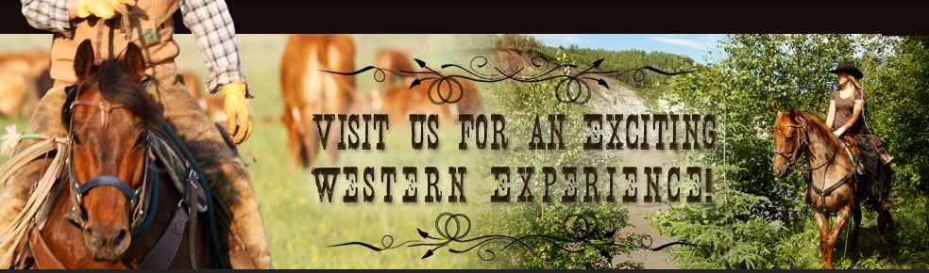
Riverwood Ranch Ride Sanctioned and Sponsored by ERA July 25

Ride Location: From H16 go north past Evansburg on RR 75. Turn east/right on Twp 544. Turn north/left on RR71. Follow Riverwood Ranch and ERA signs. App. 18 km from Evansburg.
Watch for moose!
Ride camp will be open Friday am
Fees: 50 miles Senior $70 Youth $60 Junior $50 Start: 7 am
25 miles Senior $45 Youth $35 Junior $30 Start: 8 am
12 mile introductory/fun ride $20 Start: 10 am
*Non ERA members extra $15 to ride any distance
Juniors (under 16) must wear a helmet and be accompanied by an adult 18+
Bring your own potable water. Water for horses will be available.
It is preferred your dogs are left at home. If you must bring them, they MUST be on leash at ALL times.
Lunch will be provided to volunteers, riders and crew.
Meat for dinner will be provided. Please bring a salad or dessert, and your own plate and cutlery. Donations from any extra guests will gratefully be accepted.
Head Vet: Andy Mueller Ride Manager: Nancy Tomalty
Please email: henriksonbrenda@gmail.com (780 325-2348) prior to July 18 with number attending to assist with planning and meal preparation.

